TWU Snow Removal Protocols

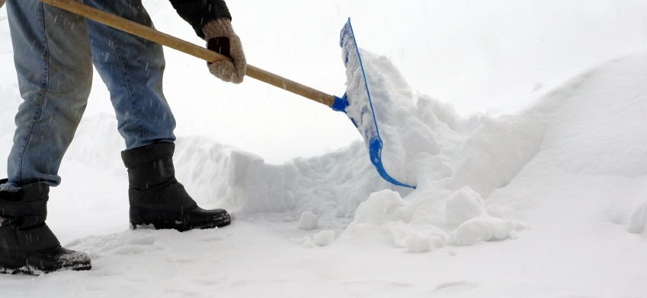

- Maintenance/Grounds Staff will assess weather conditions on an ongoing basis. Once we have a snow fall (or expected snowfall) of more than two inches, Maintenance will contact our sub-contracted snow removal service to attend Campus.
- The contractor is responsible for clearing all roadways and accessible parking lots
- Maintenance/Grounds Staff are responsible for clearing snow from footpaths, walkways, stairs across Campus.

AFTER HOURS EVENTS

- Upon an accumulation of snow of more than two inches during the night, TWU Security will be responsible for assessing the site. Security personnel will then call the “On-Call” Maintenance person who will attend TWU and mobilize resources as needed. (Contractor and TWU Maintenance/Grounds Staff).

Paul Johnston M.A.
Director of Campus Services

