PARTICIPATORY ACTION RESEARCH USING “WONDER WORKSHOP” ROBOTS TO TEACH GROWTH MINDSET AND HABITS OF MIND IN AN INCLUSIVE ELEMENTARY SCHOOL STEM CLASSROOM
by
KAREN VAN EGMOND
B.Ed., Trinity Western University, 1995
CAPSTONE PROJECT SUBMITTED IN PARTIAL FULFILMENT OF THE REQUIREMENTS FOR THE DEGREE OF

MASTERS OF ARTS IN EDUCATIONAL STUDIES- SPECIAL EDUCATION
in the
SCHOOL OF GRADUATE STUDIES
TRINITY WESTERN UNIVERSITY
AUGUST 2019

Acknowledgments
This project would not have been possible without the support many people. This has truly been a collaborative effort.
I am thankful for the village-- My parents, my family, my friends, my church, my school, my cohort, my colleagues- past and present. You have cheered me on, prayed for me, celebrated my successes, and shared in my frustrations. You knew when to feed me, encourage me, send me gifs, or set me straight. I promise I can be fun again, now.
Thank you to my co-teaching colleagues, who supported and believed in me. You allowed me into your classrooms, debriefed and reflected, and challenged me to succeed. And to my students who inspire me daily.
Thank you to my TWU cohort friends who along the way shared my vision, questioned and critiqued, laughed and cried, leaned and learned with me.
Thank you to my TWU professors and educators who edited, emailed, cheered and taught me. You expected excellence and spurred me on. Thank you, Ken, for recognizing that teaching is more than knowledge, it is an understanding of the heart. And to Yu-ling—we negotiated this together, mess and all!
My girls—Anna, Ruthie, and Elyse—for putting up with mom’s “crazy” the last 2 years. I want you to know that I did this for you. I believe you can: be smart, dream, achieve, fight, love, be kind and work hard. I love you and I have no greater joy than to hear that my children are walking in the truth” (3 John 1:4).
And to Michael. My rock, my source of strength, my love, my cheerleader, my anchor, my protector. You fought when I couldn’t and told me never to quit. You held us together so that I could chase a dream. You are more than enough. Solo deo Gloria

Table of Contents
Acknowledgments ii
Table of Contents iii
List of Tables and Figures vi
Abstract vii
Chapter 1: Introduction and Background 1
Definition of terms 1
STEM education 1
Wonder Workshop Robots 2
Habits of Mind 2
Growth Mindset 2
Background 2
Research Questions 4
Statement of the Problem 4
Chapter 2: Literature Review 6
STEM Education 6
Inquiry learning 7
Figure 1-- P21 Framework 9
Robotics in STEM education 9
Growth Mindset and STEM education 10
Figure 2- Growth Mindset and Achievement 11
Fixed vs. Growth Mindset 11
Habits of Mind 12
Metacognition 13
Perseverance 14
Thinking and Communicating with Clarity and Precision 16
Thinking and Learning Interdependently 17
Conclusion 17
Chapter 3: Method 18
Introduction 18
Rationale and Description of Research Methodology 18
Reliability 19
Summary 20
Chapter 4: Research Design 22
Introduction 22
Research Participants 23
Participant and Parental Consent 23
Ethical Considerations 24
Procedure 24
Research questions 25
Research Space: The ExploZone and Universal Design for Learning (UDL) 26
Data Collection and Analysis 27
Teaching the lessons 28
Photos 28
Reflection sheets 29
Table 1-- What, So What, Now What Structure 29
Learning with the Wonder Workshop Robots 30
Reliability 30
Timeline 31
Chapter 5: Results and Limitations 32
Introduction 32
Interpretation of Results 32
Table 2-- Themes and subthemes 33
Coding 33
Pre and post-test surveys 34
Table 3-- Pre and Post survey results 34
Figure 3-- Pre-Test Wordle 35
Figure 4—Post-Test Wordle 36
Figure 5- Pre-Survey Photos 37
Figure 6—Post Survey Photos 38
Personal reflective journal 38
Interviews 39
Table 4-- Semi structured interview questions 40
Table 5-- Student Themes and supporting quotes 41
Teacher Themes 42
Table 6-- Teacher Themes and Supporting quotes 43
Discussion of Themes 46
Collaborative Grouping: The shift from independent thinking to interdependent partnerships 46
Explicit teaching leads to increased understanding of a concept 47
Increased Teacher Reflection 47
Recognizing the Power of Co-teaching 48
Transfer of Growth Mindset to different subject areas 48
Developing a safe learning environment that allows for risk-taking, design thinking, and iterative learning 49
Final Thoughts and Limitations of the Study 50
References 53
Appendix A- Dweck’s Growth Mindset Survey 60
Appendix B-- A General overview of the Habits of Mind (Costa & Kallick, p. xx-xxi) 61
Appendix C—Locally Developed Survey for Pre and Post Test 62
Appendix D-- Dash Lesson Planning 63
Appendix E -- Picture books recommended for teaching Growth Mindset 65
Appendix F- Pre and Posttest Survey responses used to create the Wordle Documents 66

List of Tables and Figures

FIGURES

Figure 1-- P21 Framework 9
Figure 2- Growth Mindset and Achievement 11
Figure 3-- Pre-Test Wordle 35
Figure 4—Post-Test Wordle 36
Figure 5- Pre-Survey Photos 37
Figure 6—Post Survey Photos 38

TABLES

Table 1-- What, So What, Now What Structure 29
Table 2-- Themes and subthemes 33
Table 3-- Pre and Post survey results 34
Table 4-- Semi structured interview questions 40
Table 5-- Student Themes and supporting quotes 41
Table 6-- Teacher Themes and Supporting quotes 43

Abstract

In this study, Growth Mindset and Habits of Mind were introduced to elementary students through scaffolded lessons while using Dash and Dot robots in an inclusive STEM classroom. Structured lessons that taught elements of Growth Mindset and Habits of Mind allowed the students to participate in different ways of knowing and learning. This participatory action research demonstrates that when students practice Growth Mindset behaviours, their attitudes toward school and potential academic achievement improve. Using the Habits of Mind-- persistence, communication, metacognition, interdependence and risk-taking-- students were able to demonstrate a greater awareness of the power of yet and increased their understanding of learning in community and in the core competencies. In addition, teacher attitudes of the experience of co-teaching, and reflective practice are explored and discussed.

Tags: persistence, communication, metacognition, risk-taking, Habits of Mind, Growth Mindset, STEM, participatory action research, core competencies, BC curriculum, Wonder Workshop Robots

Chapter 1: Introduction and Background
Science, Technology, Engineering and Math (STEM) education was introduced by the National Science Foundation and the No Child Left Behind Act (2001) to reform education and respond to the lack of qualified Science and Math teachers (Sanders, 2009). Research has shown that STEM is a powerful interdisciplinary approach to learning (Gess, 2017) and that Costa and Kallick’s (2008) Habits of Mind are transforming student learning environments into highly tactile, integrated, and reflective spaces. The shift to core competency (Loveland & Dunn, 2014) lessons has made using robots an important addition to elementary classrooms. Students are not just learning the 3R’s of Reading, Writing, and Arithmetic, they are being introduced to a fourth R, Robotics. With the understanding that: “Scaffolding knowledge construction using a guided inquiry instructional approach with robotics develops conceptual understanding, enhances critical thinking, and promotes higher-order learning in the domains of mathematics and science” (Casteldine & Chalmers, 2011, p. 19), the students and researcher used transformational action research to make sense of this new knowledge. Much research focuses on the use of robotics and STEM using LEGO mindstorms, but there is little about the highly accessible robots of Wonder Workshop (Bolkan, 2017). The use of Wonder Workshop’s Dash and Dot robots provides an active problem-solving context for learners to explore the processes of thinking and metacognition. This study set out to discover how the direct instruction of the Habits of Mind will benefit students’ growth mindset and problem-solving strategies in an elementary school STEM classroom.

Definition of terms
STEM education-- as used in the research refers to curriculum based on the idea of educating students in four specific disciplines – science, technology, engineering and mathematics. Integrative STEM education “refers to technological/engineering design-based learning approaches that intentionally integrate the concepts and practices of science and/or mathematics education with the concepts and practices of technology and engineering education… And may be enhanced through future integration with other school subjects, such as language arts, social studies, art, etc.” (Sanders & Wells, 2006)
Wonder Workshop Robots-- designed in the Silicon Valley, California, these kid-friendly and easy to use robots are used with several apps to encourage children to code, use critical thinking and to develop 21st century learning skills. They consist of two separate yet connected robots that communicate to their programmer and with each other. For the purpose of this study, the Dash and Dot robots were used along with a Wonder Pack, the coding curriculum, and an iPad.
Habits of Mind-- According to Costa and Kallick (2008, p.17), “A habit of mind is a composite of many skills, attitudes, cues, past experiences, and proclivities. It means that we value one pattern of intellectual behaviors over another; therefore, it implies making choices about which patterns we should use at a certain time.” In the context of this study, four of Costa & Kallick’s 16 identified habits will be the focus-- persistence, communication, metacognition, and risk-taking. The specific details of the Habits of Mind will be expanded on in chapter two.
Growth Mindset-- using Dweck’s (2008) research, Growth Mindset is the understanding that abilities and intelligence can mature, grow and change when given the opportunity to believe in the “power of yet.” It recognizes the power of neuroplasticity and the changing, growing brain to develop learning and thinking behaviours.

Background
To contextualize the research, it is worthwhile understanding the developmental progression that preceded the final iteration. When I was first introduced to the idea of project-based learning (PBL), inquiry learning, and STEM education, I was excited about the possibility of transforming student learning in a way that would be engaging, problem-solving, would develop critical thinking skills, integrate subjects and give voice and choice to student learning processes. I first engaged in this process with a collaborative co-teacher who walked with me as we developed a series of activities that connected to a redesign of the school curriculum from specific learning outcomes, to a competency-based curriculum. What surprised me was the fact that the challenges we presented were not often solved by my “good” students, rather, they were the outside-the-box thinkers who could try new things in different ways. And, many of them were on IEPs.
I began as a library learning commons (LLC) co-teacher and developed a STEM lab for the students in our K-5 school. We called this space the “ExploZone.” The space and its purpose will be discussed in chapter 3). Over and again, I noticed that the students with special needs were not standing out during these sessions. They were often leading the learning. I think about one student, who, in a typical classroom setting, struggled with written output, language, and math. But, in the STEM lab, he was coding, solving problems, and finding solutions for my most difficult challenges. Instead of being the last picked for a reading group, his classmates were competing for his attention in the STEM lab. His parents noticed too. He hated going to school most days, but when he knew that STEM would be part of his day, he would eagerly bounce in and get to work. The STEM lab became a source of joy and accomplishment. Reflection on this experience led to the questions: “What was it about digital and project-based learning that leveled the playing field for all learners? What made the STEM lab a safe place to take risks, to develop skills, and think differently?
One possible reason why STEM learning, specifically the use of Wonder Workshop robots, is a positive learning tool for students is that they are receiving active feedback (Hattie, 2009) for iterations. Using specific learning targets for academics and behaviour, as developed in the specific teaching of the Habits of Mind and Growth Mindset, self-efficacy in student’s visible learning through the process of setting clear, specific and attainable goals that are reviewed consistently, will encourage growth and change (Hattie, 2009). However, Hattie argues that there is potential for a larger effect size in mindset interventions if teachers can change their fixed mindset into a growth mindset. If a teacher has not yet embraced growth mindset, they will continue sending fixed mindset messages, consciously or otherwise, to the students in their classrooms (Brock & Hundley, 2017). As Hattie recognizes, feedback is important, but the potential for change in mindset could be more impacting on student learning and development.
Research Questions
The research focused on the following questions: How can STEM education, specifically the use of Wonder Workshop robots, develop a learners’ Growth Mindset?
- How can teaching specific Habits of Mind (Costa & Kallick, 2008) support students with their problem-solving strategies?
- How will integrating subject content with STEM learning benefit student understanding in other subjects, specifically in the core competencies of communication, collaboration, and critical thinking?

Statement of the Problem
Several studies involving Habits of Mind (Costa & Kallick, 2008) and STEM have been conducted at the Middle and High school levels (Vollrath, 2016), but very few have been done at the elementary school level. STEM education recognizes learner variability and when taught with specific, targeted scaffolds, using habits of mind, inquiry strategies, co-teaching, all students will be able to thrive in a STEM program (Basham & Marino, 2013).
So, in my new role as a collaborative, STEM teacher, I noticed that several accommodations can be made to benefit student learning. In the suggestions for further research, Vollrath (2016) states:
“Both Costa and Kallick stress the importance of developing the habits of mind at early levels in education. When students and teachers have a sustained focus on the habits of mind from elementary through secondary school they establish are sense of continuity and expectations (Costa & Kallick, 2008, p.216). Analyzing the beginning stages of the habits of mind within an elementary school would allow for a better understanding of how younger grade level students acquire, develop, and grow with the habits. Within an elementary school having the teachers and students utilize the habits within the curriculum and classroom would give an opportunity to find out how effective this approach could be to enhancing and building dispositions in the elementary years” (p.142)
The shift to competency-based instruction and learning allows students to engage in the process of learning rather than the product. As will be expanded upon in further chapters, it has been observed that, through this process, the participants were able to experience self-regulation, able to articulate their needs and wants, increased their collaboration skills, and communicated their learning. Therefore, the purpose of the research here is to engage students in metacognitive strategies and growth mindset while participating in targeted action research at an elementary school in British Columbia. The narrative will report on the observations of learners’ levels of engagement, changing mindsets, and provide insight into how teachers put research into practice.

Chapter 2: Literature Review

Using the search terms of Growth Mindset, Habits of Mind, STEM education, and Inquiry learning, much of the research in these areas has focused on the needs and learning of adolescents to young adults. As this project focuses on elementary students, it is pertinent to understand this limitation at the onset of this literature review.

STEM Education
Science and Technology education (STEM) has been an important part of the education system and curricular process but has been seen as an unreachable subject for those who are either scientific or not (Honey, Pearson & Schweingruber, 2014, p.1). This fixed mindset has gradually shifted in the last 50 years as integrative STEM education has become entrenched in the skills and process of competency-based learning (Basham, Israel & Maynard, 2010). Unfortunately, STEM learning has not been respected for its value in a classroom environment, in spite of its importance in the working world and the recognized benefit of 21st century skills. Although there is a need for the processes of understanding and iterations in the learning process and the powerful integrative and interdisciplinary approach to learning, there is still great misunderstanding as to what STEM education actually is (Gess, 2017).
STEM learning is the vehicle on which to drive the content. So, these integrative STE(A)M classrooms are evidence-based, differentiated, use learning targets, self-reflection and are anchored in literacy. They "connect hands-on with minds-on, where hands-on experiences are intentionally utilized to achieve minds-on learning outcomes" (Gess, 2017, p. 41). But, specific inquiry skills must be taught so that learning in STEM classrooms can be intentional, interactive, iterative, and reflective. Rotherham and Willingham (2010) state: “outlining the skills in detail and merely urging that content be taught, too, is a recipe for failure. We must plan to teach skills in the context of particular content knowledge and to treat both as equally important...we should launch a concerted effort to study how they can be taught effectively rather than blithely assume that mandating their teaching will result in students learning them” (p.19). Understanding that these skills can be taught is the foundation of inquiry learning.

Inquiry learning
In Rapp’s (2005) qualitative research study, the author determines several themes and benefits of inquiry-based learning, using the question: What kind of an inquiry environment is best for students? Eight factors were identified and divided into cognitive and social benefits. To summarize Rapp’s study:
1. Cognitive Benefits: Scaffolded instruction; meaningful and contextualized activities; self-regulated learning; activities that are responsive to learning styles, rates, and ability levels
2. Social Benefits: The learning communities; the social construction of knowledge; parental involvement
In addition, the transferability of these themes to a STEM classroom environment would be considered. By choosing one of the social or cognitive goals, it may show how inquiry learning can influence the learning community (For example: how can self-regulation affect inquiry learning?). In addition, how does play enhance learning in an inquiry environment? And, how can collaboration between teachers in a school encourage learning and growth mindset? Rotherham and Willingham (2010) state that critical thinking and problem solving, for example, have been components of human progress throughout history, from the development of early tools, to agricultural advancements, to the invention of vaccines, to land and sea exploration” (p.17). This research supports the understanding that developing Growth Mindset is critical in learning how to adapt to the competency-based instruction in our curricula:
Another curricular challenge is that we don’t yet know how to teach self-direction, collaboration, creativity, and innovation the way we know how to teach long division. The plan of 21st-century-skills proponents seems to be to give students more experiences that will presumably develop these skills—for example, having them work in groups. But experience is not the same thing as practice. Experience means only that you use a skill; practice means that you try to improve by noticing what you are doing wrong and formulating strategies” (p.19)

This research is supported by the P21 framework (www.p21.org) which identified the most desired twenty-first century skills by future employees. These skills complement those taught in STEM classrooms using inquiry learning strategies. These identified skills are: creativity and innovation, critical thinking and problem solving, communication and collaboration, flexibility and adaptability, initiative and self-direction, social and cross-cultural skills, productivity and accountability, and leadership and responsibility (Figure 1). These identified “4C’s” have influenced the changes in the current British Columbia curriculum support the learning and processes of using Robotics in STEM classrooms.

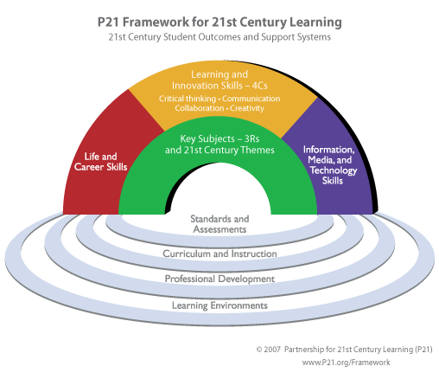

Figure 1. P21 Framework

Robotics in STEM education
Balkan (2017) states that some educators are intimidated to use robots in their classroom, but there is evidence to suggest that these student-friendly devices can aid in coding, problem-solving, help students see a purpose in their lessons, support creativity, the iterative process of design thinking, and the development of the language of coding. Robots get students to think differently and learn kinesthetically by getting them out of their seats and onto the floor—this big picture learning gives students the ability to think creatively and process information in new ways that are less traditional and more hands-on. For example, Dash and Dot robots have been used in music classes for composition practice. (Balkan, 2017, p.20). Several studies suggest that the critical thinking and processes of STEM education are in the iterative engineering component (Basham & Marino, 2013; Gess, 2017) and the importance of integrating STEM learning with other subject content will help learners develop skills and retain knowledge (Honey, Pearson, & Schweingruber, 2012). Using Robotics in STEM education will aid in interactive and collaborative learning, communication strategies, and essential problem-solving skills.

Growth Mindset and STEM education
Introduced in the research of Blackwell, Trzesniewski, and Dweck (2007), Growth Mindset is a movement toward understanding the power of neuroplasticity and brain development. This research showed that a “focus on the potential of students to develop their intellectual capacity provides a host of motivational benefits” (p.260). In an iterative STEM environment, the power of understanding that: “children with a growth mindset believe intelligence can grow and change through hard work and persistence. These children see difficult academic work as challenging and an opportunity for growth and learning. People with a growth mindset are more persistent and resilient” (Smythe, 2017, p.1).
In a STEM classroom, the implications of this can be developed using the iterative process of design thinking. Basham and Marino (2013) note: “There are times where the design, even using proven practices and evidence-based practices will not provide the desired results. When a design fails, look for evidence that supports the reason for the failure, take that evidence into consideration, and move forward with the next design solution” (p.14). Educators and need to encourage a paradigm shift from “I can’t” to “I can” (Figure 2). This can only happen if all stakeholders are invested in developing growth mindsets to encourage neuroplasticity: “it’s not just about effort. You also need to learn skills that let you use your brain in a smarter way” (Yeager & Dweck, 2012, p.305).
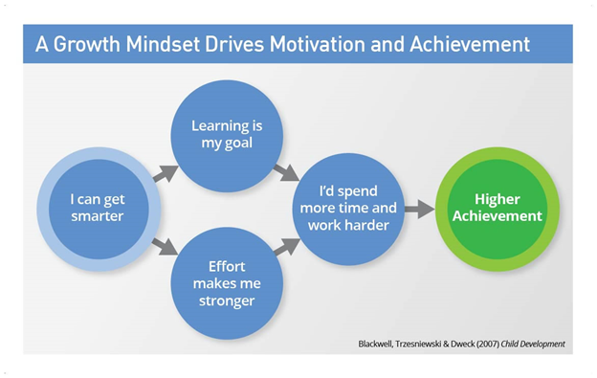Figure 2. Growth Mindset and Achievement

Further, Dweck’s research (2014) offers practical advice: “praise wisely, not praising intelligence or talent…but (try) praising the process that kids engage in their effort, their strategies, their focus, their perseverance, their improvement. This process praise creates kids who are hardy and resilient.” In a STEM classroom, the focus of the learning is on the process rather than a product. When students are taught to believe in the “power of yet” (Dweck, 2014) their emotional intelligence and academic achievement are affected.

Fixed vs. Growth Mindset
Encouraging a growth mindset that allows children to develop skills and strategies to maintain their self-regulation, organize for optimal executive functioning, and practice mindfulness can positively affect the lives of our students and children. Ultimately, changing your brain can change your life. If we allow children to understand this simple, yet powerful, reality, they will develop an attitude of resilience (Yeager & Dweck, 2012, p.306) toward difficulties and will have the experience to know how to overcome them. Acknowledging that a fixed mindset is an obstacle to critical thinking (Dweck, 2008, p. 36), a growth mindset recognizes that intelligence is fluid and can be changed with “exercise.” Just as an Olympic athlete would train his body, the intelligent person, with a growth mindset can train his brain to learn. Students who take risks, learn to think critically and develop creative problem-solving skills are comfortable in their unknowing (Miller, 2013, p. 52). Because many students do not value the power of mistake making and unknowing, the words “not yet” are rich in power and potential (Miller, 2013). One way to experience true learning is to recognize the tolerance factor-- how long can one wrestle with doubt (Miller, 2013, p. 51).
In order to develop resilience and tolerance for mistakes, students can be taught lessons in the Habits of Mind to develop their “brain muscle” and nurture the skills of perseverance, communication, metacognition, and problem-solving. Costa and Kallick’s (2008) Habits of Mind provide the foundation and structured skills needed to develop Growth Mindset in a STEM classroom. Although there are sixteen identified habits of mind (Appendix 2), for the purpose of this research, four of the habits are examined and taught to the participants in this study.

Habits of Mind
In the following section, the habits of mind -- metacognition, perseverance (persisting), communication (including questioning), and thinking interdependently (collaboration) will be explored. Specific teaching of these habits will be the focus of the action research and complement the core competencies in the British Columbia curriculum.
Teaching and Learning with Habits of Mind is not a new concept. The idea that making meaning and developing ideas is rooted in the thoughts of the early researchers and thinkers of the century. Using Dewey’s model of understanding, the social constructivist theory of learning and doing is prevalent in the thoughts and ideas that are foundational in developing the Habits of Mind in 21st century learning. A Habit of Mind is a pattern of intellectual behaviors that leads to productive actions” (Costa & Kallick, 2008, p.17). Using the foundation of Dweck’s (2008) research, the Habits of Mind recognize that educators “cannot just teach behaviours, we need these behaviours to be habitualized. Teaching students how to solve problems is a wonderful behaviour, but unless that behaviour becomes a consistent and habitual action, it will not “stick” (Costa & Kallick, 2008, p. xvii). When teaching the skills, content, and processes of learning, educators “need to develop learning goals that reflect the belief that ability is a continuously expandable repertoire of skills, and that through a person’s efforts, intelligence grows incrementally” (Costa & Kallick, 2008, p.7). This complements Dweck’s (2008) research but is broken into manageable and teachable sections.

Metacognition
To simplify, metacognition is the act of thinking about thinking. This reflective and responsive act is “what distinguishes humans from other forms of life ...the ability to stand off and examine our own thoughts while we engage in them” (Costa & Kallick, 2008, p.24). Metacognition is a critical element in the development of habits of mind and ultimately, growth mindset. Brock and Hundley (2017) describe the importance of metacognition as it will help students reflect that: completing a task involved skills and strategies that can be useful on a number of other tasks” (p.56). With practice and reflection, it is shown that the habits of mind, specifically metacognitive strategies, can be automatic when they “rehearse their thinking process, learn with the habits of mind, and develop an internal compass as a guide with these dispositions, the more potential will show in their success as a learner and teacher” (Vollrath, 2016, p.140).
The British Columbia curriculum encourages the direct instruction of metacognitive strategies in the critical thinking core competency. The critical thinking competency “encompasses a set of abilities that students use to examine their own thinking, and that of others, about information that they receive through observation, experience, and various forms of communication” (BC Ministry of Education, 2017). Students are encouraged to analyse and critique, investigate and question, and develop and design. Using the habits of mind complements this learning and provides the framework for instruction.

Perseverance
Perseverance is the act of doing something in spite of difficulty and continuing even if there is there may be a delay in achieving success (Costa & Kallick , 2008) use the word “persisting” to describe this process-- Appendix A). In a society that has been characterized by its instant culture and displeasure in delayed gratification, perseverance is a life-long skill that must be fostered in schools. Teachers are often “bemoaning the fact that today’s kids aren’t problem solvers” (Brock & Hundley, 2017, p.66). But, these same teachers do not make an effort in training these desired behaviours in their students. In teaching this Habit of Mind, it is possible that rather than giving up, students will “stick to it, see a task through to completion, and remain focused” (Costa & Kallick, 2008, p. xx). This is not only a foundational skill for learning in schools, but also a desired trait for employees in the workplace.
Persevering, as a habit, encourages students to adopt the attitudes of failing forward, learning from mistakes, and planning to fail. This is the first step in “acknowledging the inevitability of struggle” (Brock & Hundley, 2017, p. 72). Explicit teaching in the power and value of failure will increase student resiliency, give students the opportunity to practice that learning is a journey and not a final destination. Persevering on a task should be built into the culture of classroom learning so that students understand that “true learning requires multiple attempts” (Brock & Hundley, 2017, p. 76).
Persisting in learning provides the groundwork for Growth Mindset and will develop a student confidence, self-awareness, metacognitive strategies, and self-talk. Through self-reflective journals in his research, D. Vollrath (2016) found that students recognized that: “persevering in tasks was a way to improve” (p. 104). Persisting with metacognitive strategies will provide the tools needed for student success. This supports the research of Brock and Hundley (2017), as they provide strategies for teaching these habits of mind and growth mindset by teaching students to take responsible risks: “Students who are capable of being different, going against the grain of common thinking, and thinking of new ideas (testing them with peers and teachers) are more likely to be successful in an age of innovation and uncertainty” (p.33). Persistence and metacognitive strategies are foundational in shifting student confidence and thought, but it is in understanding communication and questioning that the habit of mind will become part of life and the real world (Vollrath, 2016, p. 141).
In the core competencies of the British Columbia curriculum, students are encouraged to develop their personal awareness and responsibility through persevering in challenging tasks. “Students who demonstrate personal awareness and responsibility demonstrate self-respect and express a sense of personal well-being” (BC Ministry of Education, 2017). In teaching this habit of mind, it is likely that students will develop a sense of accomplishment and self-determination.

Thinking and Communicating with Clarity and Precision
Costa and Kallick (2008) encourage learners to “be clear, strive for accurate communication in both written and oral form, avoid overgeneralizations, distortions, and deletions” (p.xx). Clear communication is at the core of understanding in both teaching and learning. Students who have the ability to question and reflect on their learning are able to fill in the gaps between what they know and what they don’t know (Brock & Hundley, 2017, p. 26). Communication strategies, such as journaling, developing student oral and written communication, reflective practice, and give opportunity to solve solving complex problems. In articulating their learning, students can “develop a methodology for optimal learning” (Brock & Hundley, 2017, p.57). Unfortunately, schools commonly permit the use of vague and imprecise language, but as Vollrath (2016) shows in his research, students with clear communication strategies are less anxious, have higher school achievement, and greater social interaction (Vollrath, 2016, p. 37). In addition, British Columbia’s curriculum (2017) considers the competency of communication to be foundational in developing understanding:
The Communication competency encompasses the set of abilities that students use to impart and exchange information, experiences, and ideas, to explore the world around them, and to understand and effectively engage in the use of digital media. Communication competency provides a bridge between students’ learning, their personal and social identity and relationships, and the world in which they interact.
For the purpose of this study, teaching students to develop their written competency through reflective journals will develop this competency and increase student understanding. In addition, these journals will be collated to determine the emerging themes and the direction of further research.

Thinking and Learning Interdependently
This habit of mind is characterized by the ability to work together and to learn from others in reciprocal situations (Costa & Kallick, 2008, p. xxi). Learning is a collaborative process; when effective collaboration takes place, a group of learners is more intellectually and physically powerful, than any one individual (Costa & Kallick, 2008, p. 36). Huskens, Palmen et al. (2015) studied the interactive play of Lego robotics with children and noted that the specific collaborative behaviours were interaction initiations, responses, and play together. In a classroom environment, these behaviours are observed among students, but “play together” may be exchanged with “learn together.” Interdependent learning is a key to academic achievement and social success. The old saying “two heads are better than one” is true in collaborative learning. In the British Columbia core competencies (2017), learning interdependently connects the competencies of communication, personal and social awareness, and critical thinking. Using these competencies in tandem, develops metacognitive awareness, clear communication, and perseverance.

Conclusion
The research describes an interdependence of habits of mind and growth mindset. Knowing that specific language and strategies can be taught, students will develop the critical thinking and metacognitive awareness that is needed to solve complex problems in a collaborative setting. In addition, the Wonder Workshop robots will be used as a tool to facilitate the learning. As we move toward elaborating on how this project unfolded, it is imperative to recognize that the goals and competencies of the British Columbia curriculum have been used to guide teacher practice in this study. This curricular link gives clear understanding, direction, and objectives to this research and will encourage all participants to develop their growth mindset as they practice their habits of mind.

Chapter 3: Method

Introduction
Teachers, as reflective practitioners, are continuously evaluating, assessing, understanding, and changing their methods and practice to reach the students in their classrooms. For this study, the use of Participatory Action Research allowed for a transformative approach to data collection and analysis while exacting change in student learning and behaviours. Understanding that the teacher is the researcher and therefore the instrument for collecting data, the researcher used autoethnographic journals to track personal and co-teachers’ involvement in this study (Mertens, 2015, p.261).
The research questions addressed in the study have been answered using action inquiry research and qualitative methodology. According to Creswell (1994), "A qualitative study is defined as an inquiry process of understanding a social or human problem, based on building a complex, holistic picture, formed with words, reporting detailed views of informants, and conducted in a natural setting.” Using the familiar setting of the school STEM lab (ExploZone) with a known teacher, the rich data that reflective learning journals, surveys, interviews, and observations can provide will help to recognize developing patterns that trend toward perseverance, metacognition, and growth mindset.

Rationale and Description of Research Methodology
Participatory Action Research allows participants to share in the process of research “with,” not research “on” students (Mertens, 2015, p.250). This cooperative inquiry approach is based on the “importance of self-determination… generating ideas, designing and managing the project, and drawing conclusions from the experience, and also as co-subjects, participating in the activity being researched” (Mertens, 2015, p.250). Using a co-teaching model, this transformative action research seeks to exact change in the classroom community and school culture by developing an insight into the reflective practices of the students, teacher, and the researcher.
Based on the work of Paolo Freire (1921-1997), the direct instruction in this project is contextualized by the active participation of the learners and their critical thinking processes. This participatory action research is characterized by “collective, self-reflective inquiry that researchers and participants undertake, so they can understand and improve upon the practices in which they participate and the situations in which they find themselves. The reflective process is directly linked to action, influenced by understanding of history, culture, and local context and embedded in social relationships” (Baum, MacDougall, Smith, 2006, p. 854). The purpose of this research is to understand rather than predict and control (McDonald, 2012). In learning specific Habits of Mind as they connect to Growth Mindset, students and teachers were able to take action, reflect on their learning and make critical connections to a variety of curricular areas.

Reliability
The researcher conducted formal and informal checks with the stakeholders throughout the study to ensure that the voice of the people was accurately reflected. In order to maintain credibility, peer debriefing (with students, teachers, and researchers), persistent observation (documented in researcher journals) and member checks were used after each teaching session and after the final survey. Research dependability is the “interpretive paradigm’s parallel standard for reliability… change is expected… (so)… the researcher who works within this paradigm does have a responsibility to track the change and provide a … record of the change process (Mertens, 2015, p.398). In addition, the researcher conducted an independent review of the data with a colleague and administrator who was invested in, but had not participated in, the study. This triangulation process recognized the possibility of bias in data collection and interpretation and gave the stakeholders voice to represent the “what, the why and the how” of their learning (Mertens, 2015, p.409).

Summary
Through this qualitative participatory action research, and using ethnographic methods, the researcher in the role of the classroom co-teacher assessed the impact that the lessons on growth mindset influenced the transferability and knowledge of the “power of yet” (Dweck, 2007) on classroom learning and school climate for change. The action researcher seeks to tell the story of a marginalized group of people specifically in the areas of social justice and reform. This primarily qualitative methodology attempts to provide a framework that is balanced and fair. According to Mertens (2015), this approach is valid if it includes the criteria of fairness, ontological authenticity, community, attention to voice, positionality, reciprocity, and the catalytic authenticity to stimulate social change (p. 273-274). The role of the researcher is to be the instrument to collect the data and information while entering into the lives of the people. This way of knowing provides rich data and understanding. In knowing the people or group, there is a reality beyond numbers and the story of the people will be clear: “critical consciousness development requires the individual to be knowledgeable about political, social, and economic contradictions, and to take action to change the oppressive elements of reality, thus liberating oppressed individuals” (Freire, 1970, in McDonald, 2012, p.37). There is a recognition of the position of power held by the researcher, but the goal is that the researcher becomes an agent of change (Mertens, 2015, p. 251) for the community.
Transformative change comes through experience. The power of this paradigm is in the stories that are told. In the following chapters, the story of how students developed their skills in communicating, collaborating, iterating, and advocating will be shared as the researcher describes the implementation, practice, struggle, and success of Growth Mindset and the Habits of Mind. In addition, the positive changes that co-teaching and reflective practice can have to support a transformation in teacher and student attitudes are documented and explored as the themes emerged. The action research process allowed for all participants to demystify and build ownership of the project (McDonald, 2012, p.40) while creating a space for trust, collegiality, and meaning-making.

Chapter 4: Research Design

Introduction
The fundamental belief of this project and for the STEM classroom is that the iterative engineering process and targeted intervention to develop the growth mindset, will allow for the design of a learning environment that is conducive to risk-taking, incorporating the core competencies, while encouraging students to think critically, speak and listen for understanding, work collaboratively with others, and persevere when things get difficult.
While using ethnographic techniques, such as journals, student reflections, teacher responses, and student interviews, several themes emerged. As expected, focused teaching of concepts, vocabulary, attitudes, and ideas began to show in student responses. This research-based approach to teaching confirmed what the literature had to say about growth mindset (Dweck, 2008) and student achievement. The more obvious we were in explaining and integrating the habits of mind (Costa & Kallick, 2008), the more we would see them in student work, reflections, conversations, and practice. The transformative practice of participatory action research was becoming clear and our co-teaching was making an impact. The following pages will describe the learning environment, the participants, and will discuss the results according to the emergent themes of self-regulation, collaboration/ working interdependently, communication, perseverance/persistence, critical thinking/ metacognition.
Brantlinger et al (2005) determine that action research is when “the researcher brings ideas for practice to fieldwork to have an impact on the setting/participants while collecting data” (p.197). When planning this study, the researcher recognized the importance of the different needs of the students in the group. Through scaffolding the instruction to meet the individual and corporate needs of the students in the group and to help in developing multiple connections to the new knowledge, the researcher hypothesized that there would be an increase in understanding of problem-solving skills and a development in the areas of perseverance, risk-taking, and communication of learning. As Mertens (2015) suggests, this research recognized the importance of universal design for learning in representation, expression, and engagement (p.410).

Research Participants
The participants were a sample of convenience for the researcher. With the support and direction of the school administrator, the researcher chose a group in the school community that was eager, had willing co-teaching participants, independent enough to take direction, and would use their new knowledge to influence and grow the school community goals and vision in the future. This participatory action research targeted three grade three classes in a public elementary school in the Fraser Valley of British Columbia. The school is a dual-track (English and French immersion) with 552 students in 24 divisions. The classes in this study were two grade 3 classes and one grade 2/3 class. Each class had between 22-24 students. Of the 68 grade 2 and 3 students, who had parent permission to participate in the project, 55 took the pre-intervention survey and 59 took the post intervention surveys. The researcher recognized the fact that not all students participated in both surveys but realized the importance of the available data as a snapshot of the learning process that was meaningful, authentic, and in the moment.

Participant and Parental Consent
Students and parents were provided with a detailed description of the study and were asked to give permission for their children to participate (see appendix X). As this study aligns with the Applied Skills and Design curriculum of British Columbia and supports the learning in the regular classroom, the study was curricular in nature and used self-reflection as a valuable tool in the learning process: “Regardless of whether students succeed or fail in reaching their goals, they should reflect on the process” (Angell, Stoner & Fulk, 2010, p.71). This had been an identified area in the targeted classrooms and has been developed as a reflection of the participating teachers’ wishes for this project. One of the three classes of students shared their learning using an online portfolio, Seesaw learning. Parents, as partners, were able to respond and reflect with their child during this process. Seesaw learning is an online learning and reflection platform. It is “simple way for teachers and students to record and share what's happening in the classroom. Seesaw gives students a place to document their learning, be creative and learn how to use technology. Each student gets their own journal and will add things to it, like photos, videos, drawings, or notes” (https://web.seesaw.me/seesaw-for-schools). Increasing student and parent involvement supports learning of self-efficacy (Hattie, 2009) and self-determination (Niemiec & Ryan, 2009).

Ethical Considerations
The researcher applied for Human Ethics Review from the board at Trinity Western University and was approved with minimal risk to the participants to begin research in March 2019. In addition, the researcher received approval from the Abbotsford School District and the school administrator. Student participation was voluntary, and participants were advised that they could remove themselves from the study at any time. All responses were collected and stored in a password protected computer file, in a locked filing cabinet, or off-campus.

Procedure
The study began in April 2019 and was carried through till June 2019. The targeted lessons focused on specific language and actions of the habits of mind (Costa & Kallick, 2008), and were delivered in the classrooms or in the STEM makerspace (ExploZone) of the school. The targeted research group had no prior experience with the Dash and Dot robots. The interactive nature and built in capacity for learning skills in the Wonder Workshop curriculum supported the learning of Growth Mindset. Students were encouraged to understand that the robots are the tools to learn the skills, much like a pencil is used to communicate the skill and process of writing. Details of the learning targets and specific lesson plans will be discussed in the following pages. As well, there is a link to the slideshow for each lesson plan in appendix 3.

Research questions
The research focused on the following questions: How can STEM education, specifically the use of Wonder Workshop robots, develop a learners’ Growth Mindset?
- How can teaching specific Habits of Mind (Costa & Kallick, 2008) support students with their problem-solving strategies?
- How will integrating subject content with STEM learning benefit student understanding in other subjects, specifically in the core competencies of communication, collaboration, and critical thinking?
The themes were coded using coloured highlighters and recorded in separate word documents on a password protected computer. During the initial coding process, the researcher coded for patterns (Saldana, 2013) and noticed repeated words and phrases in each of the documents collected from students, teachers, administrators, and the researcher’s notes. The second round of coding linked the data into themes. Saldana (2013) notes the importance of “shop-talking” through the themes to determine unique questions and connections in the data. Using this method, the researcher noticed that the co-teachers were often saying the same things independent of one another. The third round of coding the data solidified the themes and allowed for analysis. Using the Wordle “word cloud” process (Saldana, 2013, p.199), the student and teacher responses were collated and analyzed in light of the habits of mind (Costa & Kallick, 2008) and growth mindset (Dweck, 2008) research.
Student journals, reflections, and interviews were coded and assigned themes of collaboration (working interdependently), self-regulation, perseverance (persistence), communication, problem-solving (critical thinking), and metacognition. Co-teacher reflections were collected and coded based on the themes of self-regulation, communication, collaboration, self-reflection, critical thinking, and persistence. In addition, the researcher recognized the importance of personal story and used the autoethnographic approach to journaling and reflection notes.

Research Space: The ExploZone and Universal Design for Learning (UDL)
The ExploZone, by design, is an active makerspace in the school. Students are invited to discover different ways of learning, inquiry and thinking. Guided by the Library Learning Commons (LLC) teacher, who is also the researcher, the room was supplied with 30 Dash and Dot robots. In not knowing how to use them best, I decided to base this participatory action research on the Wonder Workshop inquiry tools after reading about the influence of STEM and the ADST curriculum. The ExploZone is a flexible work space equipped with a variety of learning tools such as Lego, a green screen, various building tools and materials, mobile workspaces, games, iPads, computers and a variety of tech-learning tools . According to CAST (http://udlguidelines.cast.org/2011), several of the principles of UDL are at work in this space: options for physical action, options for expressive skills and fluency, options for self-regulation, options for recruiting interest, and options for sustaining effort and persistence (in Mertens, 2015, p. 410). . However, it has not always been this way. Before we began the project, I asked the co-teachers to read my literature review and asked them to reflect on this in light of our project. I had observed that the three classes were struggling with the idea of persistence and perseverance and knew from the research of Dweck (2008), and Costa & Kallick (2008) that this was an identified habit of mind and of growth mindset that needed to develop before real change in attitude and experience of growth mindset could happen. Ultimately, these UDL themes were echoed in the reflections of the students and teachers. One of the co-teachers commented during her reflection: “having space to lie down on the floor is very effective for many of the BOYS! They often choose to do this.” Basham & Mariano (2011) state: “as an instructional design framework, UDL uses both instructional practices and modern instructional materials and tools (e.g., technology) to provide an engaging learning environment for as many learners as possible” (p.11). The ExploZone is just this—a place where students and teachers can engage in participatory, inquiry-based learning that is engaging, self-regulating and reflective.

Data Collection and Analysis
Students participated in a locally developed pre and post survey (Appendix 2) based on Dweck’s (2007) growth mindset attitude survey to determine the difference and effect of the lessons. Using the intervention protocol identified by Blackwell, Trzesniewski, and Dweck (2007), students were taught specific strategies on their brain (structure and function), memory intervention, and study skills. Survey questions included:
- I am a problem-solver
- I can ask questions to help me learn
- I can work with a friend
- I can use my words to tell people what I learned
- I can learn new things
- I know my brain can grow through learning experiences
These survey questions align with the core competencies described in the British Columbia curriculum (2017). An open-ended response question: “How do you know your brain can grow?” was also included in the pre and post test survey.
Additionally, students were interviewed by the researcher to determine their confidence and attitudes toward the Habits of Mind and Growth Mindset. The follow up interview questions were structured to each of the three Habits of Mind. Three students per class were chosen at random to answer the questions:
What was a highlight of this project?
What was it like to work with a partner? Did it help you?
Do you remember what these words mean? - perseverance, persistence, growth mindset
How does working with Dash and Dot help your learning?

Student responses were recorded by the researcher and member checked after each interview to ensure that their voice and meaning were accurately reflected.

Teaching the lessons
The lessons were designed to be interactive and engaging (Appendix G); each one was structured around a specific learning target and was followed up with a reflective journal, sharing circle, SeeSaw Learning portfolio post, or an exit slip. Each week would build on the next. Using design thinking and reflective feedback, the co-teachers and I developed a plan of action to create a common language in the classrooms. The teachers were encouraged to elicit critical thinking through open-ended questioning and response.

Photos
During each lesson, the co-teacher and I took photos of the students learning. This gave us an opportunity to share with parents using the online SeeSaw learning portfolio and to use the photos to aid in student recall of the project. At the end of this project, students were asked to self-assess their learning as it related to the Core Competencies and use this as part of their end of the year reporting to their parents. This connected the learning in the STEM classroom to the authentic learning in the regular classroom.

Reflection sheets
Using the research question: How will integrating subject content with STEM learning benefit student understanding in other subjects, specifically in the core competencies of communication, collaboration, and critical thinking, students were given a 3-question reflection sheet. Using the structure of “What, So What, Now What” (Gear, 2018), students answered:

Table 1

What, So What, Now What Structure

What? | Can you tell me 3 things that you know about Growth Mindset and how it will help you learn?
So What? | After we read “The Most Magnificent Thing”—think about the times when the girl had a fixed mindset. What did she do to get out of it and change to a growth mindset? If you were her teacher, what speech/ pep talk would you give her?
Now What? | How can you bring your new knowledge of Growth and Fixed Mindset into working with Dash and Dot?

Marzano (2007) notes that “asking students to identify and record their areas of confusion not only enhances their learning but also provides the teacher with valuable diagnostic information” (p.39). The integrative nature of STEM education (Gess, 2017) which is characterized by intentional development of understanding, became the foundation for the learning with the Wonder Workshop robots.

Learning with the Wonder Workshop Robots
The Wonder Workshop Robots were introduced to the students after the introductory lesson of Growth Mindset and Habits of Mind. However, the robots were not the primary focus of the project, rather Dash and Dot were used to reinforce the learning that was taught. They were used to drive the content so that the goals we chose would become habitual (Costa & Kallick, 2008, p. xvii) and a “hands-on, minds-on” (Gess, 2017, p. 41) intentional, interactive, iterative, and reflective learning experience.

Reliability
The researcher conducted formal and informal checks with the stakeholders throughout the study to ensure that the voice of the people was accurately reflected. In order to maintain credibility, peer debriefing (with students, teachers, and researchers), persistent observation (documented in researcher journals) and member checks were used after each teaching session and after the final survey. Research dependability is the “interpretive paradigm’s parallel standard for reliability… change is expected… (so)… the researcher who works within this paradigm does have a responsibility to track the change and provide a … record of the change process (Mertens, 2015, p.398). In addition, the researcher conducted an independent review of the data with a colleague and administrator who was invested in, but had not participated in, the study. This process recognized the possibility of bias in data collection and interpretation and gave the stakeholders voice to represent the “what, the why and the how” of their learning (Mertens, 2015, p.409). Using triangulation, the results were confirmed by observations, reflection journals, formal and informal teacher observations.

Timeline
The survey was administered to a group that was not connected to the study but was a grade 5 class in the same elementary school. This pilot testing provided helpful feedback and revealed the need for clarity in questioning. Because the class had been taught several lessons on growth mindset, they were proficient in articulating their knowledge and thinking of growth mindset. In order to check the wording and viability of the research scale, the pilot survey responses were collected, but these results are not included the research data as they were only used confirm the wording and questioning of the locally-developed pre and posttests.
Once the pilot study had been completed, the pre-intervention surveys were given to the research group. In order to get a raw example of student attitudes to the question: “Can you give some examples of how you know your brain can grow?, no pre-teaching of growth mindset or habits of mind preceded this survey. Finally, students were given a posttest after all the lessons were delivered to measure changes in attitudes and reflections of growth mindset. These were anonymous surveys. The results of the survey and the measured change are discussed in chapter 5, Results and Limitations.

Chapter 5: Results and Limitations

Introduction
For the purpose of discussing the results of this project, it is necessary to reflect on the questions that have guided this participatory action research.
- How can teaching specific Habits of Mind (Costa & Kallick, 2008) support students with their problem-solving strategies?
- How will integrating subject content with STEM learning benefit student understanding in other subjects, specifically in the core competencies of communication, collaboration, and critical thinking?
The initial hypothesis of this research was that, by the end of the intervention, students in the research group would become more proficient in the language of code, would take risks in their learning and grow their critical thinking and problem-solving skills. As expected, these themes emerged. In addition, themes of collaboration, reflection, and co-teaching became evident to show that the benefits of learning and teaching growth mindset through action research supported student learning and improved educational praxis.

Interpretation of Results
Using transformative methodology in the constructivist paradigm, the researcher coded the journals, responses and surveys to draw out the themes. As shown in Table 2, students reflected most on persistence/ perseverance, collaboration, and self-regulation. The themes of critical thinking/ metacognition and self-reflection of learning were present, but not as obvious in the reflective writing as the others. They were embedded and intertwined with the themes of communication and self-talk.

Table 2

Themes and subthemes

Theme | Sub Themes
Self-regulation | - Communication with a partner  - Self-regulation behaviours
Collaboration/ working interdependently | - Shift of responsibility from individual to collaborative learning  - sharing ideas and asking questions  - group success vs. individual goal
Perseverance/ persistence
Self-Reflection of learning | - self-talk when problem solving
Critical thinking/ metacognition | - problem-solving

In addition, several themes from teachers emerged. They supported the guiding questions and confirmed the research. The transformational action research bridged the research practice gap and began to shift the reflective practice of the teachers involved in the project.

Coding
Initially, the journals, responses, student work, and teacher reflections were coded by searching for patterns in responses (Saldana, 2013, p.5). These emerging patterns were then categorized (Saldana, 2013, p.9). A transcript of the original responses can be found in Appendix F. Using the emerging themes from the written work, the interviews and teacher reflections were coded using patterns. The themes were member checked with the co-teachers to refine the results. From this, the themes were categorized into student results and teacher results. In order to ensure rigor, the researcher and co-teachers discussed and reflected on their purpose and learning throughout the research period.

Pre and post-test surveys
A 5-point Likert scale survey was administered before the direct teaching of the lessons (Appendix B). Table 4 illustrates the results and the shift in attitude from the pre and post surveys. There is a slight change in the measurement of attitudes, but the observable change in metacognition and reflection is not quantifiable in graph form. The pre-test results can be explained through the lens that student responses were based on what they thought their teacher wanted to know and hear. I believe the minimal change between the pre and post surveys shows that students became more reflective during the intervention. In addition, this triangulated the data recorded in the students’ reflective journals, check in sheets and the post intervention interviews.

Table 3

Pre and Post survey results

In addition, an open-ended question “Can you give me some examples of how you know your brain can grow” was added to the bottom of the survey. The answers to this question were collated and transformed into a Wordle. These word clouds (McNaught and Lam, 2010) showed the most prevalent words associated with the coded research responses of the pre and post-test answers. The larger words show the most frequently used words in response to the question.

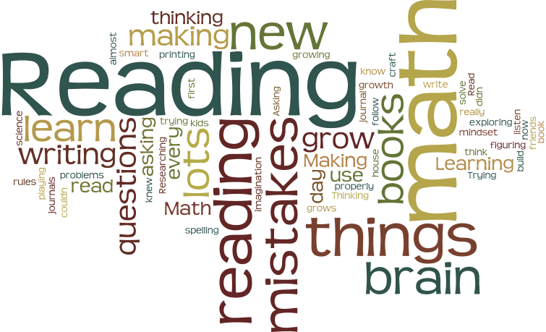

Figure 3.Pre-Test Wordle

Initially, students recorded “Reading” as the most prominent word in how they know their brains can grow. The character of the words shared is mostly connected to academic subject areas and what students thought their teacher might want to hear them say. In the post-test Wordle, the results are more varied and supply the teacher-researcher with a deeper understanding of the change that direct instruction of the Habits of Mind had on the reflective practice of the students (FIGURE 4). Rather than “reading” students had recognized the power of learning “new things, making mistakes, and having their brains grow.”

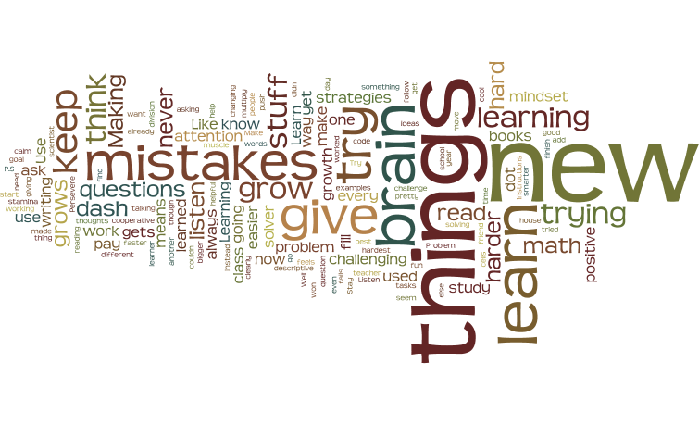

Figure 4.Post-Test Wordle

The results of the pre-survey can be qualified by observing how the students completed the task. Because students were quick to complete their pre-test surveys, I invited them to draw or write on the back of their pages. Illustrations from the pre-survey show a lack of understanding or no prior knowledge of the subject. Participants drew a picture of the Dash robot or left the page blank (FIGURE 5).

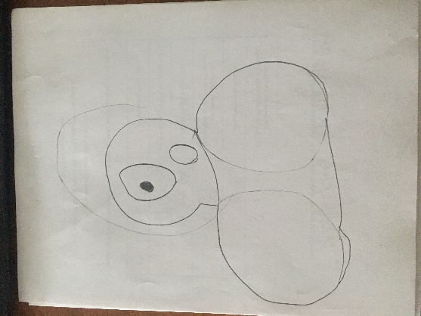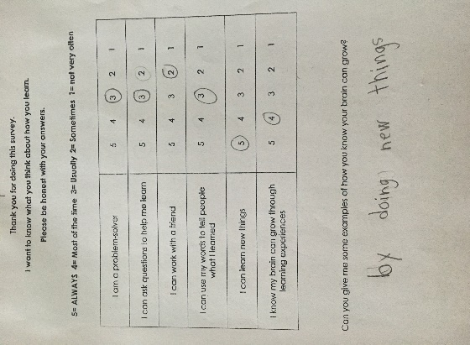

Figure 5. Pre-Survey Photos

The post survey shows something very different. Students were able to complete the post-survey but commented they had more to tell me. This is when they began to show what they remembered and had reflected upon during the intervention. The photos show that the participants were eager to share their learning. They used a web or a list to record their enduring understandings. The themes of self-regulation, persistence, collaboration, metacognition, communication in this self-reflection are evident (FIGURE 6)

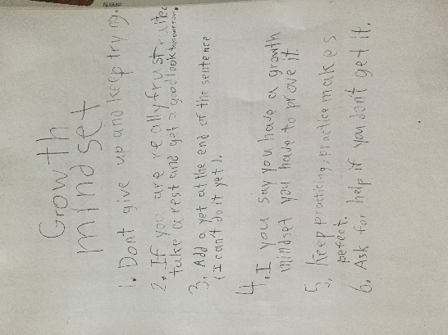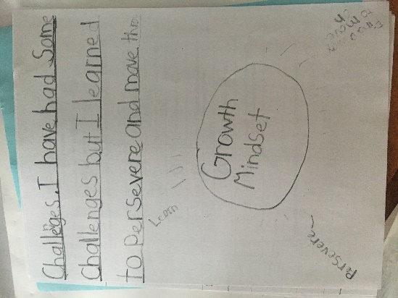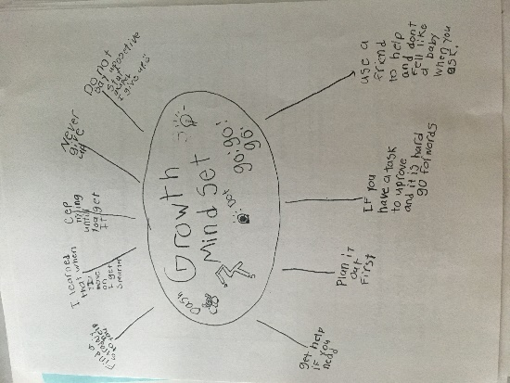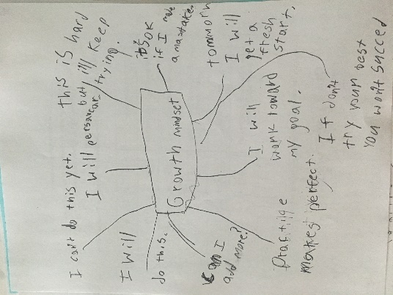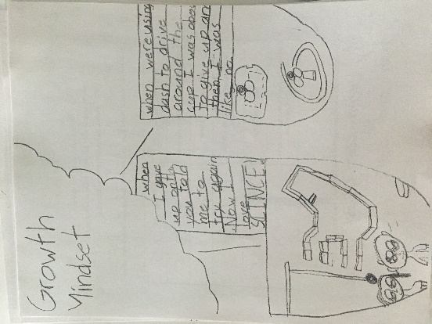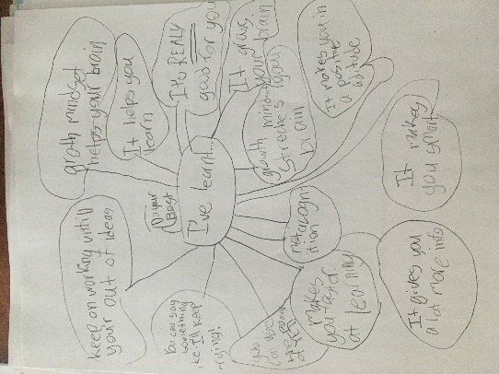

Figure 6.Post Survey Photos

Personal reflective journal
The researcher took reflective field notes through the process. This allowed for reflective change and iterations to the lesson planning in response to student learning and practice. These journals were also coded for patterns (Saldana, 2013, p.5) and put the action researcher in the role of a transformative party in the lived experience. The shift to reflective practice among the researcher and the co-teachers recognized the needs of the students and contributed to a clearer understanding of the why, what and how of growth mindset. From a journal entry on May 20:
- Many answers were subject specific-- learning reading, writing, math
- Students were eager to see what the others were doing-- some wrote: making mistakes, thinking
- No examples of growth mindset or collaborative activity and how they help people learn
- Not creative-- seems like they were writing what we wanted them to say
In the journal entries of this week, there is a marked shift in the way I wrote. Something seemed to connect with the students; they had the building blocks for success, but they needed the “luxury of time to share and explain their thinking” (May 16 journal entry). It was also the time where the co-teacher and I decided that the lesson was too long, and it needed to be split into two parts. I began to wonder:
- Have students become more reflective over the course of this project?
- Because they have become more reflective, are they “harder on themselves” and more honest in their responses? Is that going to show when I interpret the data from the surveys?

Interviews
Three students from each class were randomly selected for post intervention interviews. These interviews were informal and took place two weeks after the post survey. Students were asked to recall the events, share personal highlights, and recall terms to give voice to their learning. The researcher sat with each responder and recorded the responses verbatim. As a form of a member check, the answers to the questions were reread to the responders to clarify or correct any errors.

Table 4

Semi structured interview questions
1. | Can you tell me a highlight of this project?
2. | How does working with Dash and Dot help your learning?
3 | Do you remember what these words mean?  - Perseverance  - Persistent/ persistence  - Growth Mindset  - Interdependence  - Metacognition
4. | What was it like to work with a Partner (collaboration)? Did it help you?

The purpose of the semi-structured interview determined whether the teaching had become habitual and to see if there was any need for reteaching a habit. The responses were coded (Saldana, 2013) to determine any emerging patterns. Even though the interviews took place two weeks after the intervention, the responses indicate that the learning behaviours had become habitual. In response to the question: “How does working with Dash and Dot help your learning?” students responded with the following: (Table 5)

Table 5

Student Themes and supporting quotes
THEME | STUDENT QUOTES
Students had become more reflective during the process | “It helps me try a different way if it doesn’t work It helps me have a growth mindset; if I can’t do something, I try it in a different way and don’t give up”  “my brain has grown, I know how to do more things, like code, and Dash and Dot taught me how to make my brain grow”  “You have to look at things different ways. You are going to have to do that a lot when you are older”
Students were transferring knowledge to other subject areas (Math, Reading, Art, Science) | “When I was at home, I didn’t understand my math, my mom gave me a hint and I figured it out. It got easier and easier”  “It helps me do Science, cooperation; and creativity—you can be creative with Dash and Dot for the wonder workshop”
Students recognized the power of collaboration | “… it helped me work better it felt like I was actually going on pretty good without disagreement; we came up with something that everyone would like”
Students were engaged in the learning and using self-monitoring behaviours for self-regulation and their Growth Mindset | “It helped me a lot. It taught me to collaborate better because I don’t collaborate with my brother. It might teach me to work with my brother more. Now I talk things out a bit, take a break if I need it and talk to him again”  “My partner was Carson, it helped me worked a lot better, you need someone to help you if you get frustrated, I help other people calm down sometimes you look at it one way and your partner looks at it a different way. If I didn’t have Carson, I wouldn’t have been able to solve the blockly problems”  “I think more positive thoughts because you wonder about fixed mindset and you won’t try to have a fixed mindset if you have a wrong answer”

Teacher Themes
In response to the reflection and on-going conversation, the need to have the teacher’s voice included in this research became evident. The collaborating teachers and the school administrator were given a questionnaire and were asked to complete it within a week of the final lesson. Every teacher complied with the request. In addition to the themes from students, teachers provided another voice and perspective to the learning.

Table 6

Teacher Themes and Supporting quotes
Theme | Supporting Quotes
Collaborative Grouping: The shift from independent thinking to interdependent partnerships | “Children collaborating and helping each other and trying new ways with a mindset that learning will come with time and perseverance”  “The tasks were developed to facilitate interdependent/collaborative work. Students did very well managing in their inclination to take the robot/materials and just do the task alone rather than to work with peers”
Explicit teaching leads to increased understanding of a concept | “I always start the year by doing a lot of mindset work, but I now want to incorporate it throughout the year in a more intentional/ purposeful way—I need to actually schedule it in as if it were its own subject rather than rely on “incidental” teaching”  “It’s very important that we teach and model the skills we want our students to use. We cannot assume that they know the skill until we have explicitly taught it. Integrating the skills into all areas of curriculum reinforces the learning. Having students share new knowledge/ skills at home encourages transfer to other areas of life and perhaps teaches the families as well which could provide more support for what we are doing at school.”
Increased Teacher Reflection | “I will use the language and mindset to help instill growth mindset, perseverance and resilience in all activities and praise the process and acknowledge students when they too model these behaviours and adopt this mindset”  “This shows that if teachers want to change ideas and practice, they need to be specific about their goals and practice.”
Recognizing the Power of Co-teaching | “I noted staff talking about the positive impacts of this type of learning and an increased ability to consider how they might incorporate mindset or group problem solving beyond the tech/stem activity. The teacher discussions also extended to the power of working with the LLC teacher and the benefits of learning/practicing new(er) skills or concepts together would increase likelihood they would do more on their own”.
Transfer of Growth Mindset to different subject areas | “Students who would usually get easily frustrated during Art now have a much more positive outlook! Instead of crying or getting angry, they simply start over and try again!”  “Students who previously would appeal for help while reading, are now using a greater number of strategies… persevering! When decoding”  “We had many discussions of how we were using a growth mindset. Students would explain how characters in books had a growth/ fixed mindset demonstrating their understanding. L shared about encouraging his Dad to use a growth mindset at home with a challenge”
Developing a safe learning environment that allows for risk-taking, design thinking, and iterative learning | “having space to lie down on the floor is very effective for many of the BOYS! They often choose to do this.”  “It’s changed the dynamic of “tough learning time” in the classroom.”  “choosing an appropriate partner helped them to stay more regulated”  “They were honest about their trials and tribulations and celebrated successes of themselves and others”

Discussion of Themes

Collaborative Grouping: The shift from independent thinking to interdependent partnerships

Around week three, my reflections show that there was a shift. When I used videos to connect the learning and gave examples from the Habits of Mind, the “aha moment” happened. We also shifted the responsibility to students for group choice—in recognizing that students needed to communicate their learning and that they were motivated to complete the task, we allowed students to keep the same group or pairings. This was transformative. Not only did the conversations grow deeper, there was also a growing respect among partnerships. Robert Marzano (2007) confirmed that “group size might moderate the effects of learning in groups… which implies that groups should be kept relatively small” (p.40). He continues by confirming that pairs or triads are the most effective learning groupings. As co-teachers, we decided to establish learning partnerships for the students. These teacher-chosen pairings were deliberate and specific. We determined that these pairings would be the partners for the remainder of the sessions. Although we recognized student choice in their learning environment, it was important to determine that these learning partners were intentional and in the best interest in the learning time. Up to this point, we had allowed students to switch partners each session, but we decided it was important to develop the relationship of trust in partnership. Once students recognized that we had their best interest at heart, students accepted this reality and began to notice that that their chosen partner was someone they could relate to and work with. In subsequent sessions, students realized that they had been able to go deeper in their learning now that the “awkward” stage of their working relationship had morphed into a relationship of trust and discovery. Although not every partnership experienced the same success, the precedent was set for the Habit of Mind “working interdependently.”

Explicit teaching leads to increased understanding of a concept
I heard once that “if you want it, teach it.” Meaning, if you want to see a result, teach your students the behavior. Because all behavior is learned and can be taught, my co-teachers and I wanted to see students persevere. So, we taught them the basics of persistence and perseverance and gave them a chance to practice it. We saw results in their discussions and reflections. In knowing and understanding the authentic community with intentional teaching, there will be observable change. This is one of the transformative limitations of the study. In this type of research, it is important that the teacher maintains a “guide on the side” position so as not to derail the process of making mistakes and persevering through. Students were encouraged to demonstrate their ability to fail forward and make mistakes to see their process as a learning journey not as a destination.

Increased Teacher Reflection
Further, interviewing teacher attitudes and perceptions of co-teaching and growth mindset may change the school culture and develop a collaborative environment for learning and sharing. Much of the research suggests that, when teachers have growth mindset, the effect on students is measurable. As this study focuses on changes in student learning, it would be beneficial to provide future coaching to develop the mindset shift. Brock and Hundley (2017), caution educators against a “false growth mindset” where hollow “overpraising” for efforts that are not measurable counters the promise of growth mindset. Teachers, in their efforts to encourage growth mindset have unknowingly practiced the antithesis (p.11). Increasing teacher awareness of their personal fixed or growth mindsets will likely allow students to experience meaningful mentoring in their ability to grow their habits of mind: Part of the 21st-century-skills movement’s plan is the call for greater collaboration among teachers. Indeed, this is one of the plan’s greatest strengths; we waste a valuable resource when we don’t give teachers time to share their expertise” (Rotherham & Willingham, 2010, p.19). Teachers are the catalyst for developing habits into the learning environment hence it is their job to model and “incorporate successful dispositions as much as they can” (p.157).

Recognizing the Power of Co-teaching
Using the co-teaching models described by Friend and Bursuck (2012, p.92), this co-teaching plan, based on a relationship of trust and collegiality, became one of the positive contributing factors to this study. The teaming approach encouraged an inclusive environment for all students and gave students access to the feedback of more than one adult. Each co-teaching team was able to develop an equal partnership that was communicative and open. In modeling and using a growth mindset with the understanding of the UDL model, the co-teachers supported the learning environment and welcomed the feedback, reflection, and co-planning that characterize a co-teaching relationship: “(I) want to build on successes and initial discovery learning next year… I will use the language and mindset to help instill growth mindset, perseverance and resilience in all activities and praise the process and acknowledge students when they too model these behaviours and adopt this mindset” (From co-teacher reflection notes).

Transfer of Growth Mindset to different subject areas
One caution of STEM education is that it can be seen as play or unintentional learning. Oftentimes teachers are reluctant to try this way of learning because they cannot quantify the results. Using UDL principles which celebrate, the power of the understanding, the process of learning and the affective changes, this project showed teachers that they can embed different ways of knowing into their assessment practices. For example, the final maze project incorporated several Geometry concepts and encouraged children to use the language of code: “I’m always learning new things so I can add on to what I already know…I can do math faster and use more descriptive words in my writing” (student reflection).
Assessing students on the process of understanding and their reflection of their iterative design challenge developed their critical thinking skills while engaging them in the activity. The intentional nature (Gess, 2017) of STEM education allowed for positive risk taking in learning and a connectedness of concept to practice. Many of the lessons used picture books to connect this knowledge. The students understood the practical task when they had the experience and practice of literature-based instruction. Many of these suggested resources can be found in Appendix E.

Developing a safe learning environment that allows for risk-taking, design thinking, and iterative learning
In the ExploZone, it was observed that students were willing to try new things when they were given choice and opportunity, used the “power of yet” (Dweck, 2008), and knew their efforts would be celebrated by supportive collaborators and coaches. “The active problem-solving process and steps took (them) beyond trial and error…they persevered with the task – it was inherently engaging, and the rewards were entwined within the activity, being able to make it work, being able to share and problem solve and celebrate as a team” (From teacher reflections). This environment allowed for collaborative work, self-monitoring and self-regulating behaviours. Students were mindful in their interactions and recognized their need for support when they struggled with a challenge: “With learning by mistakes working with a friend and being cooperative” (Student reflection). Additionally, reciprocity united student conversations as they worked to complete a task: “I made mistakes, I tried new things, I worked with people…I didn’t give up” (student reflection). This iterative design thinking celebrated the process and skills of learning and engaged students in different ways of demonstrating their understanding. As students practiced Growth Mindset in the ExploZone, they brought their Habits of Mind to their classrooms: “It’s changed the dynamic of “tough learning time” in the classroom” (from teacher reflection notes). Together, teachers and students benefitted from the process.

Final Thoughts and Limitations of the Study
The purpose of this transformational action research was to assess and shift the mindset of the participants in the study. In doing so, there is the hope that the long-term effects of growth mindset and improved student achievement will have a positive effect on the students and teachers involved. The tangible shift of thinking from “I can’t do this” to “I’ll try, and if I make mistakes, I’ll try a different way” supports the core competencies instruction in the BC curriculum, gives roots to deeper understanding, and allows students to make valuable cross-curricular connections in their learning.
When students were able to use the design process, there were opportunities to refine and define their critical thinking skills. Future research could explore a connection to the core competencies in a longitudinal study of inclusive STEM elementary. The limitations of time did not allow for the full impact transformative action research can have to affect best practice in a school. A transformational difference was observed and recorded during this project, but will students recognize the importance of growth mindset long after this study is done? We know that explicit teaching makes a difference, but what are the long-term effects of this learning. A follow up interview or post test to determine if the thinking had become habitual (Vollrath, 2016) would allow for deeper understanding of the complexities of the Habits of Mind. This study was completed in the Spring, but it might be more valuable to have done this in the Fall when classroom communities are being formed.
The theory of self-determination, which was first described by Edward Deci (1996), was as work here as well. Increased reflection in both teachers and students: “are enhanced when individuals are self-aware, set goals and problem solve, know how to select appropriate accommodations, and know when to ask for additional assistance” (Angell, Stoner, & Falk, 2010, p.71). The time limitations of this project did not allow for a full exploration of this theory at work as it relates to growth mindset. Future research that focuses on self-determination in STEM environments could be considered to further this project.
The ecological validity of the project, given the role of the co-teacher and the collaborative participatory action research, supported the changes in student perceptions and attitudes. Having an administrator who wanted to see this project flourish was a positive and unique limitation to this study. This was a successful project because of the relationship that the co-teacher and LLC researchers had with one another. To further this research, it would be important to explore how co-teaching can encourage growth mindset and develop habits of mind in a general elementary classroom by including the attitudes toward growth mindset in teachers and administration and the effects on student attitude toward learning. Vollrath (2016) states: “Like anything, if we do not experience or practice skills, behaviors, and dispositions, the less we are able to implement successfully in life.”
Because of time constraints, this study only focused on three of the identified Habits of Mind. For future research, a long-term study that measures the pre and post attitudes of elementary students who have been taught all sixteen (Appendix B) Habits of Mind over the course of a school year would further the research that this project began.
By participating in this study, it is hopeful that applied skills and design thinking in STEM education will be entrenched in the fabric of the best practice in a school. Developing the Habits of Mind in Growth Mindset will give voice and choice to students, inspire people to try something new, and it will celebrate the importance of social-emotional learning in the classroom. The connection to the core competencies in the British Columbia curriculum and the use of a tactile and high interest tool in the Wonder Workshop robots confirms that scaffolded, direct instruction of the Habits of Mind and Growth Mindset can elicit a positive shift in attitudes toward student learning and achievement in an inclusive STEM environment in students and teachers.

References

Adams, K., & Cook, A. (2014). Using robots in “Hands-on” academic activities: a case study examining speech-generating device use and required skills. Disability and Rehabilitation: Assistive Technology, 1-11. doi:10.3109/17483107.2014.986224
Angell, M. E., Stoner, J. B., & Fulk, B. M. (2010). Advice from Adults with Physical Disabilities on Fostering Self-Determination during the School Years. TEACHING Exceptional Children, 42(3), 64-75. doi:10.1177/004005991004200307
Autoethnography: An Overview | Ellis. (n.d.). Retrieved from http://www.qualitative-research.net/index.php/fqs/article/view/1589/3095
Baker, C. K., & Galanti, T. M. (2017). Integrating STEM in elementary classrooms using model-eliciting activities: responsive professional development for mathematics coaches and teachers. International Journal of STEM Education, 4(1). doi:10.1186/s40594-017-0066-3
Basham, J. D., & Marino, M. T. (2013). Understanding STEM Education and Supporting Students through Universal Design for Learning. TEACHING Exceptional Children, 45(4), 8-15. doi:10.1177/004005991304500401
Baum, F., McDougall, C., & Smith, D. (2006, October). Participatory action research. Retrieved from https://www.ncbi.nlm.nih.gov/pmc/articles/PMC2566051/ J Epidemiol Community Health 2006; 60:854–857. doi: 10.1136/jech.2004.028662
BC Ministry of Education (2017). The British Columbia curriculum: Building student success. Retrieved from: https://curriculum.gov.bc.ca
Bergold, J., & Thomas, S. (2012). Participatory Research Methods: A Methodological Approach in Motion. http://www.qualitative-research.net/index.php/fqs/article/view/1801/3334, 13(1), 30.
Blackwell, L. S., Trzesniewski, K. H., & Dweck, C. S. (2007). Implicit Theories of Intelligence Predict Achievement Across an Adolescent Transition: A Longitudinal Study and an Intervention. Child Development, 78(1), 246-263. doi:10.1111/j.1467-8624.2007.00995.x
Bolkan, J. (2017). Promoting STEM through Robotics: Robots Are Playing a Bigger Role in the Classroom, Making Lessons More Active, Kinesthetic and Play-Based. THE Journal (Technological Horizons In Education), 44(4), 20.
Brantlinger, E., Jimenez, R., Klingner, J., Pugach, M., & Richardson, V. (2005). Qualitative Studies in Special Education. Exceptional Children, 71(2), 195-207.
Brock, A., & Hundley, H. (2016). The growth mindset coach: a teacher's month-by-month handbook for empowering students to achieve. Berkeley: Ulysses Press.
Brock, A., & Hundley, H. (2017). The growth mindset playbook: a teacher’s guide to promoting student success. Berkeley: Ulysses Press.
Brydon-Miller, M., & Coghlan, D. (2014). The big picture: Implications and imperatives for the action research community from the SAGE Encyclopedia of Action Research. Action Research, 12(2), 224-233. doi:10.1177/1476750314533135
CAST: About Universal Design for Learning. (2019, April 23). Retrieved from http://www.cast.org/our-work/about-udl.html?utm_source=udlguidelines&utm_medium=web&utm_campaign=none&utm_content=homepage#.XQh4eYhKg2w
Castledine, A. R., & Chalmers, C. (2011). LEGO Robotics: An authentic problem solving tool?. Design and Technology Education: An International Journal, 16(3).
Cook-Sather, A. (2012). Translating learners, researchers, and qualitative approaches through investigations of students’ experiences in school. Qualitative Research, 13(3), 352-367. doi:10.1177/1468794112451022
Costa, A. L., & Kallick, B. (Eds.). (2008). Learning and leading with habits of mind: 16 essential characteristics for success. Alexandria: ASCD.
Creswell, J. W. (1994). Research design: Qualitative, quantitative, and mixed methods approaches. Thousand Oaks: Sage Publishing
Devers, A. (2015). Thinking about Intelligence: How Student Mindsets Influence Academic Performance. A Rising TIDE, 8, 1-23. Princeton University Press. doi:10.23943/princeton/9780691161013.003.0004
Dweck, C. S. (2008). Mindset: The new psychology of success. New York: Random House Digital, Inc..
Dweck, C. S. (2008). Mindsets and math/science achievement: Prepared for the Carnegie Corporation of New York-Institute for Advanced Study Commission on Mathematics and Science Education. New York: Carnegie corporation.
Education, Empowerment, Transformation - Freire Institute. (2019). Retrieved from https://www.freire.org
Friend, M. P., & Bursuck, W. D. (2012). Including Students with Special Needs: A Practical Guide for Classroom Teachers. Upper Saddle River, NJ: Prentice Hall.
Gear, A. (2018). Powerful Understanding: Helping students explore, question, and transform their thinking about themselves and the world around them. Pembroke Publishers.
Gess, A. H. (2017). Steam education: separating fact from fiction. Technology and Engineering Teacher, 77(3), 39-41.
Hattie, J. (2009). Visible learning: A synthesis of meta-analysis of education. London: Routledge.
Honey, M., Pearson, G., & Schweingruber, H. (Eds.). (2014). STEM integration in K-12 education: Status, prospects, and an agenda for research. Washington, DC: National Academies Press. doi:10.17226/18612
Hong, Y. Y., Chiu, C. Y., Dweck, C. S., Lin, D. M. S., & Wan, W. (1999). Implicit theories, attributions, and coping: A meaning system approach. Journal of Personality and Social psychology, 77(3), 588.
Huskens, B., Palmen, A., Van der Werff, M., Lourens, T., & Barakova, E. (2015). Improving collaborative play between children with autism spectrum disorders and their siblings: The effectiveness of a robot-mediated intervention based on Lego® therapy. Journal of autism and developmental disorders, 45(11), 3746-3755. DOI: 10.1007/s10803-014-2326-0
Lake, D., & Wendland, J. (2018). Practical, Epistemological, and Ethical Challenges of Participatory Action Research: A Cross-Disciplinary Review of the Literature. Journal of Higher Education Outreach and Engagement, 22(3), 11.
Loveland, T., & Dunn, D. (2014). Teaching engineering habits of mind in technology education. Technology and Engineering Teacher, 73(8), 13.
Macbeth, S. (n.d.). Participatory Action Research. Retrieved from https://www.participatorymethods.org/glossary/participatory-action-research
MacDonald, C. (2012). Understanding Participatory Action Research: A qualitative research methodology option. Canadian Journal of Action Research, 13(2), 34-50.
Marzano, Robert J. (2007). The art and science of teaching: A comprehensive framework for effective instruction. Alexandria: ASCD.
McDuffie, K. A., & Scruggs, T. E. (2008). The Contributions of Qualitative Research to Discussions of Evidence-Based Practice in Special Education. Intervention in School and Clinic, 44(2), 91-97. doi:10.1177/1053451208321564
McNaught, C., & Lam, P. (2010). Using Wordle as a Supplementary Research Tool . The Qualitative Report, 15(3), 630-643. Retrieved from https://nsuworks.nova.edu/tqr/vol15/iss3/8
Mertens, D. M. (2014). Research and Evaluation in Education and Psychology: Integrating Diversity With Quantitative, Qualitative, and Mixed Methods. Thousand Oaks, CA: SAGE Publications.
Miller, D. L. (2013). Got it wrong? Think again and again. Phi Delta Kappan, 94(5), 50-52. doi.org/10.1177/003172171309400511
Mishra, P., & Kereluik, K. (2011, March). What 21st century learning? A review and a synthesis. In Society for Information Technology & Teacher Education International Conference(pp. 3301-3312). Association for the Advancement of Computing in Education (AACE).
Niemiec, C. P., & Ryan, R. M. (2009). Autonomy, competence, and relatedness in the classroom. Theory and Research in Education, 7(2), 133-144. doi:10.1177/1477878509104318
Rapp, W. H. (2005). Inquiry-based environments for the inclusion of students with exceptional learning needs. Remedial and Special Education, 26(5), 297-310. doi:10.1177/07419325050260050401
Roehrig, G. H., Johnson, C. C., Moore, T. J., & Bryan, L. A. (2015). Integrated STEM education. In STEM Road Map (pp. 35-50). Routledge.
Rotherham, A. J., & Willingham, D. T. (2010). “21st-Century” skills. American Educator, 17, 17-20.
Saldana, J. (2013). The Coding Manual for Qualitative Researchers (2nd edition). Thousand Oaks, CA: SAGE.
Sanders, M. E., & Wells, J. (2006). Integrative STEM Education Course Syllabi & Instructional Materials: STEM Education Foundations; STEM Education Trends & Issues, STEM Education Seminar. doi:10.25152/ser.2011.59.3.729
Sanders, M. E. (2008). Stem, stem education, stemmania. Retrieved from: https://vtechworks.lib.vt.edu/bitstream/handle/10919/51616/STEMmania.pdf?sequence
Sanders, M. E. (2012). Integrative STEM education as “best practice”. Griffith Institute for Educational Research, Queensland, Australia.
Searle, M. (2013). Causes and cures in the classroom. Alexandria: ASCD
Smyth, S. (2017). A Growth Mindset Approach to Supporting Children Who Experience Anxiety. dspace.library.uvic.ca
Vollrath, D. (2016). Developing Costa and Kallick’s habits of mind thinking for students with a learning disability and special education teachers. Graduate Theses & Dissertations. 5. https://scholarworks.arcadia.edu/grad_etd/5
Willms, J. D., Friesen, S., & Milton, P. (2009). What Did You Do in School Today? Transforming Classrooms through Social, Academic, and Intellectual Engagement.(First National Report).Toronto, Canada: Canadian Education Association, 2009
Yeager, D. S., & Dweck, C. S. (2012). Mindsets that promote resilience: When students believe that personal characteristics can be developed. Educational psychologist, 47(4), 302-314. doi:10.1080/00461520.2012.722805
Yeager, D. S., Romero, C., Paunesku, D., Hulleman, C. S., Schneider, B., Hinojosa, C., ... & Trott, J. (2016). Using design thinking to improve psychological interventions: The case of the growth mindset during the transition to high school. Journal of educational psychology, 108(3), 374. doi:10.1037/edu0000098

Appendix A- Dweck’s Growth Mindset Survey

Psychologist Carol Dweck (1999, 2006) created the 3-item Growth Mindset Scale to measure how much people believe that they can get smarter if they work at it. Researchers have used this scale primarily with students, including college students whose parents did not complete a four-year college degree (i.e., first-generation college students) and high school students living on a low income in Chile (Claro, Paunesku, & Dweck, 2016). Researchers have also used this scale with adults (Thompson et al., 2013), although not with adults in poverty.

(Survey and explanation taken from-- Stanford University SPARQ online tool kits
http://sparqtools.org/mobility-measure/growth-mindset-scale/#all-survey-questions)

Read each sentence below and mark the choice that shows how much you agree with it. There are no right or wrong answers.

1. You can learn new things, but you can't really change your basic intelligence.

Strongly  disagree | Disagree | Somewhat  disagree | Somewhat  agree | Agree | Strongly  agree
2. Your intelligence is something about you that you can't change very much.

Strongly  disagree | Disagree | Somewhat  disagree | Somewhat  agree | Agree | Strongly  agree
3. You have a certain amount of intelligence and you really can't do much to change it.

Strongly  disagree | Disagree | Somewhat  disagree | Somewhat  agree | Agree | Strongly  agree

Appendix B-- A General overview of the Habits of Mind (Costa & Kallick, p. xx-xxi)

1. Persisting. Stick to it. See a task through to completion, and remain focused
2. Managing impulsivity. Take your time. Think before you act. Remain calm, thoughtful, and deliberate.
3. Listening with understanding and empathy. Seek to understand others. Devote mental energy to another person’s thoughts and ideas. Hold your own thoughts in abeyance so you can better perceive another person’s point of view and emotions.
4. Thinking flexibly. Look at a situation another way. Find a way to change perspectives, generate alternatives, and consider options.
5. Thinking about thinking (metacognition). Know your knowing. Be aware of your own thoughts, strategies, feelings, and actions—and how they affect others.
6. Striving for accuracy. Check it again. Nurture a desire for exactness, fidelity, craftsmanship, and truth.
7. Questioning and posing problems. How do you know? Develop a questioning attitude, consider what data are needed, and choose strategies to produce those data. Find problems to solve.
8. Applying past knowledge to new situations. Use what you learn. Access prior knowledge, transferring that knowledge beyond the situation in which it was learned.
9. Thinking and communicating with clarity and precision. Be clear. Strive for accurate communication in both written and oral form. Avoid overgeneralizations, distortions, and deletions.
10. Gathering data through all senses. Use your natural pathways. Gather data through all the sensory paths: gustatory, olfactory, tactile, kinesthetic, auditory, and visual.
11. Creating, imagining, innovating. Try a different way. Generate novel ideas, and seek fluency and originality.
12. Responding with wonderment and awe. Let yourself be intrigued by the world’s phenomena and beauty. Find what is awesome and mysterious in the world.
13. Taking responsible risks. Venture out. Live on the edge of your competence.
14. Finding humor. Laugh a little. Look for the whimsical, incongruous, and unexpected in life. Laugh at yourself when you can.
15. Thinking interdependently. Work together. Truly work with and learn from others in reciprocal situations.
16. Remaining open to continuous learning. Learn from experiences. Be proud—and humble enough—to admit you don’t know. Resist complacency

Appendix C—Locally Developed Survey for Pre and Post Test

Research survey questions for pre and post test

5= ALWAYS 4= Most of the time 3= Usually 2= Sometimes 1= not very often

- I am a problem-solver 5 4 3 2 1
- I can ask questions to help me learn 5 4 3 2 1
- I can work with a friend 5 4 3 2 1
- I can use my words to tell people what I learned 5 4 3 2 1
- I can learn new things 5 4 3 2 1
- I know my brain can grow through learning experiences
- 4 3 2 1
Can you give me some examples of how you know your brain can grow?

Appendix D-- Dash Lesson Planning

Week 0—Hand out permission forms
- Introduce the project—why is Mrs. Van Egmond doing this anyway? What is Growth Mindset and why is it important?
- Play with Dash in the ExploZone as a way to introduce and create excitement. This will be based on the challenge: Using the Wonder app, can you get Dash to dance?
- Short oral debrief to complete the challenge and get students to use metacognitive strategies
Week 1
- Complete the pre-research survey and the Growth mindset vs. Fixed mindset word sort
- Reflect on thinking using SeeSaw reflection journals and a wonder journal
- Goals: I can reflect on my learning
Pages in the wonder journal—trouble shooting page, problem solving page, glossary, evaluation rubric, Habits of Mind pages—perseverance, metacognition, thinking and communicating with clarity and precision, thinking and learning Interdependently (collaboration)
*****************************************************************************
Survey questions: Students will be asked to complete the growth mindset survey
Research survey questions for pre and post test

5= ALWAYS 4= Most of the time 3= Usually 2= Sometimes 1= not very often

- I am a problem-solver 5 4 3 2 1
- I can ask questions to help me learn 5 4 3 2 1
- I can work with a friend 5 4 3 2 1
- I can use my words to tell people what I learned 5 4 3 2 1
- I can learn new things 5 4 3 2 1
- I know my brain can grow through learning experiences
- 4 3 2 1
Can you give me some examples of how you know your brain can grow?
Week 3
Coding problems—what do you do when you can’t solve a problem? How can coding help your brain grow? Can you communicate your thinking to someone else?
Activity— Goals: reflection, perserverence, collaboration, communication
Using the challenge cards—break into 2 groups—one uses blockly and one uses wonder app. Make Dash and Dot do the sequence activity. Now, combine pairs. Each pair teaches the other how to use their app (communication/ perseverance).
Reflection: which app is easier for you? Why do you think that? Did you use communication or collaboration when you were working today? Were you successful in teaching someone to use the other app?

Week 4
Begin to build the Dash Maze—connect to Math (geometry)

Links to Google Slide Shows:
Week 1:
https://docs.google.com/presentation/d/14m7X5dyAzdH9vJM-b0ELRrzQz0o9SleFuYs2nL0PBRA/edit?usp=sharing
Week 2:
https://docs.google.com/presentation/d/1fy615skNpfSWZSVeu93A8p-CXEuiDe6g4vdoBo1DJek/edit?usp=sharing

Week 3:
https://docs.google.com/presentation/d/1fiu25b35yUT7i2rhWrgPYISQBN_kNYCp_BNGbf7wAs8/edit?usp=sharing
Week 4:
https://docs.google.com/presentation/d/1Lk9lHzVRJpyZ7N_MLo-CGS7fjLFvH1nPsHNq6eA5X2I/edit?usp=sharing

Appendix E -- Picture books recommended for teaching Growth Mindset

This is not an extensive list, but these are some of the resources we had available in our school library.

The Most Magnificent Thing by Ashley Spires
After the Fall: How Humpty Dumpty Got Back up Again by Dan Santat
What do you do with an Idea? By Kobi Yamada
What do you do with a Problem? By Kobi Yamada
Rosie Revere, Engineer By Andrea Beaty
When Sophie Thinks she Can’t by Molly Bang
The Dot by Peter H. Reynolds
Bubble Gum Brain by Julia Cook
Your Fantastic Elastic Brain by JoAnn Deak

For more lists, go to:
http://www.readingpowergear.com/
https://booksthathealkids.blogspot.com/
https://blog.reallygoodstuff.com/10-childrens-books-for-teaching-growth-mindset/
https://www.weareteachers.com/perfect-read-alouds-for-teaching-growth-mindset/
https://selfsufficientkids.com/growth-mindset-childrens-books/

Appendix F- Pre and Posttest Survey responses used to create the Wordle Documents

Pretest survey responses | Posttest survey responses
- Reading and math  - Math reading  - Math at first I couldn’t do it, but now i can  - Learning math, science,and trying new things  - Reading math  - Reading math writing  - I knew my brain was growing when I read  - Making mistakes, exploring  - Reading math spelling  - Researching and reading lots  - Reading writing making mistakes math  - Making mistakes  - By reading books and asking questions  - I read a book  - Reading making mistakes  - Reading  - Reading lots making mistakes  - Reading  - Reading  - By doing new things  - If my brain didn’t grow I would be not very smart  - We can learn new things  - I use my imagination to build things that I can learn with  - Asking questions, figuring it out yourself  - Because i learn every day  - Learning math, having friends, playing, reading, thinking  - My brain will grow by thinking  - By writing and printing in my journals  - By reading lots of books and do math  - If i learn new things my brain can grow  - By asking questions  - I know my brain grows because I do math at my house  - By reading books  - Trying new things  - I listen, I follow the rules properly, and I use a growth mindset  - Thinking  - Read lots of books  - I write a journal almost every day  - I do a craft and I really think  - I solve problems for other kids | - Learning new things  - Like a muscle when I work on a hard question  - Like when we were doing math and then we did it over again it feels easier every time and gets easier  - You can keep on going, push harder, try to finish your goal or make one. Make another way  - You should never give up even though it is very hard  - If you try your hardest and have stamina  - You can try new things and learn about them  - Stay positive  - Use yet  - Making mistakes  - If you do mistakes or if you keep trying in or stuff your brain will grow  - With learning by mistakes working with a friend and being cooperative  - I listen to the teacher in class and I can grow I can try  - I try doing new strategies if one fails  - I try different things  - I learn new things it grows and gets bigger  - If you keep on trying never give up and always be helpful  - We can learn from dash and dot  - If you listen in class and you study at your house  - By asking questions and giving examples  - I challenge myself in math, writing, and reading  - When you think positive, your brain grows cells in our brain. That means they are talking to each other and changing  - When I learn new things  - Persevere, find a way to move on, think cool thoughts  - I learn new things because I use dash to help me learn  - I never give up on challenging tasks because I want my brain to grow. Well I’m going to be a scientist, so I need my brain to grow  - Listen, follow the instructions, go to school!  - Learning about growth mindset and how to code things  - I can be a problem solver  - I learned new stuff with dash and dot  - Problem solving  - Try your best  - Use calm strategies  - Do not give up  - Learn new things and be a problem solver  - Learn new things  - I’m always learning new things so I can add on to what I already know  - I can do math faster and use more descriptive words in my writing  - I’m a good learner P.S. I think  - I made mistakes, I tried new things, I worked with people  - I didn’t give up  - I used a growth mindset and learned new things  - I make mistakes and then try again  - If you learn new stuff it grows  - I keep learning new things with my brain  - Making mistakes and keep trying means I won’t give up yet  - Making mistakes and trying something else instead of doing the same thing  - I seem smarter  - I’m learning how not to give up because at the start of the year, I couldn’t do multiply  - I used to not know division but now I get it and I read harder books now  - I work pretty hard and do more challenging stuff  - I pay attention and listen and ask questions  - I study every day and fill my brain with ideas  - I think and fill my brain  - I read for fun  - I ask questions, so I can learn clearly  - I can read harder books and pay attention

