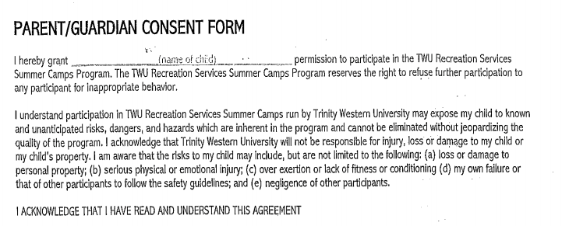

SIGNATURE: _____________________________ DATE: __________________

SIGNATURE: _____________________________ DATE: __________________

